Location Groups and Pages

Exercise 1: Investigation

1. Navigate to the **Loss Details** screen for an Auto claim. Identify the name of the PCF file that contains the currently visible element. (Choose the best shortcut depending on the information you need - the Info Page (Alt+Shift+I), the Widget Inspector (Alt+Shift+W), or Studio (Alt+Shift+E)).

What file contains the...

* 1. Tab bar (HINT: It starts with "Tab") ______________
  2. "Second-level" location group (which includes the side bar) ______________
  3. "Third-level" location group (which renders as menu links) ______________
  4. Page ______________
  5. Screen ______________
  6. Detail view ______________

Answer the following questions about the PCF file that contains the **Claim** tab's location group.

1. How many entry points does the location group have?
2. What is the name of the file that stores the location group's info bar? What sort of widget is the first (left-most) widget in the info bar? Is this widget always displayed? What about the second widget?
3. What is the name of the file that stores the location group's menu actions? What is the name of the first menu item in this file which is stored directly in this file (and not referenced by a Menu Item Set Ref) and which does something when clicked (as opposed to being a non-clickable label)?
4. In the file containing the **Claim** tab's location group, there is a location ref named Subrogation. The location ref has no visible condition, and yet it does not display when you view the Ray Newton auto claim. Why?

Exercise 2: Configuration

Configure ClaimCenter to meet the following customer requirement from Acme Insurance.

In the base application's data model, officials (police officers, fireman, coroners, and so on) are stored in the Official entity. All other people associated to the claim (insured, claimants, vendors, witnesses) are stored in the Contact entity. As a result, the list of officials associated to a claim appears on the Loss Details screen.

Adjusters at Acme Insurance find this confusing. They think of officials as part of the "parties involved" in a claim. Therefore, they have requested to have the Officials list moved to be a menu link of the Parties Involved (parent) menu link.

1. Modify the **Claim** location group so that:

* There is a new menu link off of the **Parties Involved** parent menu link between **Contacts** and **Users**. The new menu link is labeled **Officials**.
* The menu link points to a page which is labeled **Officials** in the title bar. When the screen is displayed, it is rendered in edit mode. The screen also has **Edit** / **Update** / **Cancel** buttons.
* The screen contains the Officials list view (which currently appears on the **Loss Details** screen). The list view has a toolbar with **Add** / **Remove** buttons.
* For the time being, the **Officials** list should remain on the **Loss Details** screen as well.

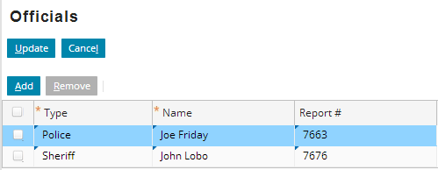

1. The ClaimCenter implementation advises that there are two approaches to meet a requirement like this: copy and modify an existing page, or build a new page from scratch. Copying and modifying an existing page is a viable option when you fully understand the functionality of the page you are copying. Many of the existing pages in the base application have functionality which may not be immediately apparent (such as permissions around who can view or edit the page). The team have provided the following tips:
2. Build the page from scratch.
3. Start first by building the page element, then refer to your new page from the parent location group.
4. Don’t forget to link your iterator buttons to your iterator.

Test Case

When you have completed your configuration, reload your changes to PCFs (Alt+Shift+L) and run the following test case:

1. Navigate to a claim. Verify that the **Parties Involved** parent menu link now includes an additional child menu link which displays the **Officials** list, and the list is initially displayed in edit mode.

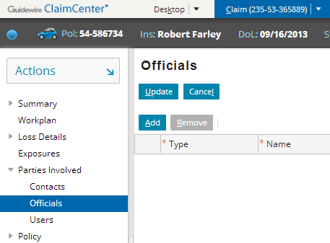

1. Add one official to the list on the new **Officials** page and one official to the list on the **Loss Details** page. Verify that both officials display in both lists.



